|  |
| --- |
| MINI PROJECT REPORT |

COMPUTER SCIENCE

WEB BASED SCHOOL ADMINISTRATION SYSTEM

SCHOOL

Name

Anjana Murali

|  |  |  |
| --- | --- | --- |
|  |  |  |
|  |  |  |

Contents

ABSTRACT 3

1. INTRODUCTION 4

1.1. Objective 4

1.2. Product Scope 4

1.3. References 4

2. REQUIREMENTS SPECIFICATION 5

2.1. External Interface Requirements 5

2.2. Functional Requirements Specification 5

3. HIGH LEVEL DESIGN 6

4. DETAILED DESIGN 7

4.1. Module Name and Description 7

4.2. Design Alternatives 7

4.3. Design Details 7

4.4. Assumptions 7

5. Project IMPLEMENTATION 8

6. CONCLUSION 9

APPENDIX A: LEARNING OUTCOMES 10

Appendix B: Glossary 11

# ABSTRACT

The school management system is a web-based system which will use as a platform for interaction between student, teachers and parents. While the main objective of this project is to computerize the paperwork in the system and automate the work. The computerization is done so that the storage of all the details regarding students and teachers will be stored in the system which makes system centralized and the chance of duplication of any data is minimized. While by doing automation to the system will reduce the time for storing any data in the system.

The school management system will manage all the work in any school in particular order so that the time requirement and complexity of the system will be reduced, at first it will focus on student related information. As a student gets the admission in the school system will start managing the details regarding the students. School Management System will then display the marksheet in printable format and provides a detailed view on extra night classes. Parents can contact the school management through the queries column.

# INTRODUCTION

## Objective

In the present School Management System, it is uneasy to store the information related to students, faculty and parents on the paper. As there is too many information, when someone tries to access any of stored information, it becomes a difficult and time-consuming task. While these days parents and faculty have more work than just take care of students, it is difficult for both parents and faculty to monitor them.

Student data management will be highly user friendly, this management information system that will not help only Accounts, Management & Administrative system to gather, communicate, computerize but also help to act on critical information much faster and in a better manner. The solution envisages linking of different departments to streamline the flow of data and timely availability of information at both the ends. Further, it also aids in generating, maintaining user definable Queries, Reports.

**Outlined objectives of the system**:

User friendliness: The package developed is easy to learn and understand. Even a new user can use the system effectively, without any difficulty. The help and user manuals are provided to solve the further queries of the users.

User satisfaction: The package is such that it stands up to the users expectations. The system is successful in generating the reports of the task status and details of the student.

Response time: The response time for all the operations is less. All the report generations and the listing tasks are performed in significant time. The queries used are so as to reduce the execution time of query processing.

Error handling: Responses to users errors and undesired situation have been taken care of to ensure that the system operates without halting. Proper error handling codes are put with the codes.

Security and robustness: The package is able to avoid or tackle disastrous action. It allows only the authentic user to access the software as it is protected by the user name and the password. All the administrative tasks are allowed to the admin only so the illegal intervention is not possible.

Maintainability: The system is able to decrease the time and effort for program maintenance. The full details of the projects being undertaken, and the task status corresponding to each student is stored carefully and the reports are generated as per the requirement.

Timeliness: The package is able to operate well under normal peak and recovery conditions.

**TIME TO COMPLETION:** 6 WEEKS

## Product Scope

This software is developed to help the department to maintain the student details. Earlier the records where maintained manually ,so this kind of web administration system will help the concerned departments to improve the productivity, reduce the time, cost factors associated with the system. The automation of the system will help the organization in proper maintenance of the record, less manpower, less man-days, less cost, proper & accurate functioning.

**BENEFITS:**

* Earlier, data pertaining to students was maintained manually.
* Manual system was not efficient.
* Cost of maintaining data manually was bigger or huge.
* Large manpower was required.
* The procedure was error prone, it was not accurate.
* Manual system was not suited for electronic exchange of data.

## References

**Books Referred:**

FUNDAMENTALS OF DATABASE SYSTEMS-----------By Ramez Elmasri and Shamkant B. Navathe

WEB DEVELOPMENT FOR BEGINEERS IN HTML------By Andy Vickler

## JAVA -THE COMPLETE REFERENCE-12TH EDITION---By Herbert Schildt

**Web Sites Referenced**:

www.w3schools.com

[www.tutorialpoint.com](http://www.tutorialpoint.com)

[www.geeksforgeeks.com](http://www.geeksforgeeks.com)

# REQUIREMENTS SPECIFICATION

## External Interface Requirements

USER INTERFACES

The GUI of the product is be designed in HTML,CSS,J-Query and Bootstrap, validation is done using javascript allowing a multitude of different users access. The system shall have content that will be viewable to the user by linking different html pages.Terms and Conditions must be agreed on registration.User’s registration details,queries are stored in database with complete security which is achieved through validation in javascript.  Also, there shall be different types of users having different accessing/viewing/modification privileges.  Also: ‘User: Admin 1 will be able to view files and grades of all users but not modify them.’

Operations:

The site shall allow authorized users to specifically modify server file system by adding files and other important changes.  The site shall allow different access permissions depending on who the user is.

HARDWARE INTERFACES

An internet connection to allow the browser software interfaces to connect to the internet to access the files of the website.

|  |  |
| --- | --- |
| Processor | INTEL i3 |
| Memory | 2-GB RAM |
| Display | Super VGA with a resolution of 1024 x 768 |

SOFTWARE INTERFACES

The basic software requirements are eclipse neon, Oracle SQL database 19c with SQL plus.

Browser Support:

Name: Microsoft Internet Explorer

Mnemonic: IE

Specification number IE7, IE8

Version number: 7.0, 8.0

Source: Microsoft.com

Purpose: To allow remote access of the website and downloading of files via the internet.

Name: Apple Safari

Mnemonic: Safari

Version number: 5.0.2

Source: apple.com

Purpose: To allow remote access of the website and downloading of files via the internet.

Name:  Opera

Mnemonic: Opera

Version number: 10.62

Source: opera.com

Purpose: To allow remote access of the website and downloading of files via the internet.

Name: Google Chrome

Mnemonic: Chrome

Version number: 6

Source: google.com/chrome

Purpose: To allow remote access of the website and downloading of files via the internet.

## Functional Requirements Specification

Student:

1.The Student shall be able to login to System.

2.The Student shall be able to view and print the Grade Report.

3. The Student shall be able to view the extra night class courses and subjects covered,

4.Complete fees structure for classes is mentioned and can register to it.

5.Connect teachers through their contact details. Personal number is not provided in website.

Teacher:

1.The Teacher shall be able to login to System.

2. The Teacher shall be able to Grade Student’s Exams.

3. The Teacher shall be able to Post Course’s lectures.

Admin:

1. The Admin Shall be able to Login to the system.

2. The Admin Shall be able to Create User login for Student/ Teacher.

3. The Admin Shall be able to add courses

4. The Admin Shall be able to delete courses.

5. The Admin Shall be able to edit courses.

6. The Admin Shall be able to assign Teachers to courses.

7. The Admin Shall be able to remove courses form teachers

8. The Admin Shall be able to change Teachers assigned to courses.

# HIGH LEVEL DESIGN

Start

Can download marksheet

Password validation

Login

Register

No Yes

Select the courses

Queries filled

Can update the values

Cannot login in

# DETAILED DESIGN

## Module Name and Description

Home module:

Deals with the overall structure of the website with the respective links to connect to the other pages.

Registration module:

This module deals with adding the user to the database with the necessary details like first name,last name,address,email-id,mobile number and password(high validation are added ).He/She is supposed to accept the terms and conditions before signing in.

Login module:

This module uses the email id and password to login to the portal.Only if the login id and password matches the one which is stored in the database ,the user can log-in.

Courses module:

This module deals with the detailed view of the subjects provided by the school.

Teachers module:

This module deals with the subject heads who will frame the syllabus of the particular subject, their contact details is provided if any queries are to fixed.

About module:

This module deals with the introduction about the school and its aspects like foreign followers,students enrolled,classes complete and certified teacher so far.Small summary of the president of the institution is also given.

Plan and pricing module:

This module deals with the schedule of online extra night classes along with the cost of the course as trial ,silver and gold.By choosing the plan,the user will be redirected to another page where a list of numbers will be given with which they can communicate to respective authorities.Numbers for certain countries are mentioned where the school branches are located.Here,the marksheet can also be viewed after filling certain details asked for. The marksheet is a link which redirects to another page where the necessary details are supposed to be filled so that the marksheet will be displayed.

Contact module:

This module is where the user can communicate or clear the queries regarding the academy or courses they provide.Here, the queries are stored in database in a separate table so that the admin can recheck whether they are valid and can be forwarded it to the required individuals.

## Design Alternatives

The verification can be done in other platforms like postman.

## Design Details

As a common design, the navigation bar and the footer is designed and attested to each page.For this module,design processing is done using bootstrap and fonts are directly attached as links.

In home module,image sliding animation is done using flex-slider ,sass is used for specific minute changes and jquery owl carousal for the loop of the text within flex slider to appear again and again. Hover is added on each image for zooming in and out.

In registration mode ,the common design is added as mentioned earlier.A form within which a table is added for the registration page and the necessary css is added.As a response to database connectivity,a page is defined inside a servlet and is linked to the existing database servlet.The response text and a log-out button is added in response servlet.

In login module,a form is created with username and password.Necessary css for alignment,color change for button etc is done.This page is also linked to external servlet page from the database servlet page.

In all the other sections,the animation with css and sass,icomoon icon fonts as link,bootstrap,separate stylesheet is created magnifying popup,flex slider,owl carousal and with separate stylesheets for each page with basic css.Mordernizr JS is used so that it must support IE9.

In each page,all js,css,jquery is linked along with the navigation bar.In jquery,min,easing,stellar,waypoints and countTo packages are imported .

Input validations are done using javascript and errors are checked and fixed using eclipse debug tool.Servlet is used for database connectivity and the database used here is Oracle 19c .The output is viewed with the help of SQL Plus.Output is stored in database­­.Error capturing is done by stacktree and by throws keyword.Performance and compatibility issues of the website is well maintained.

**Home section:**



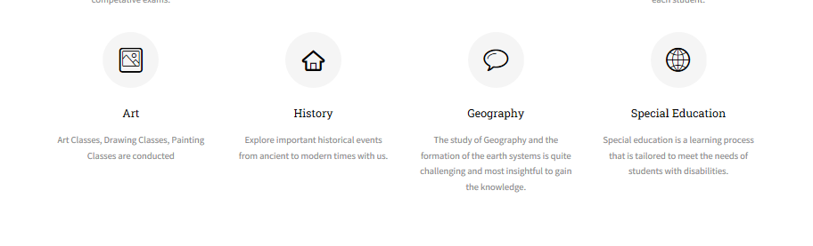



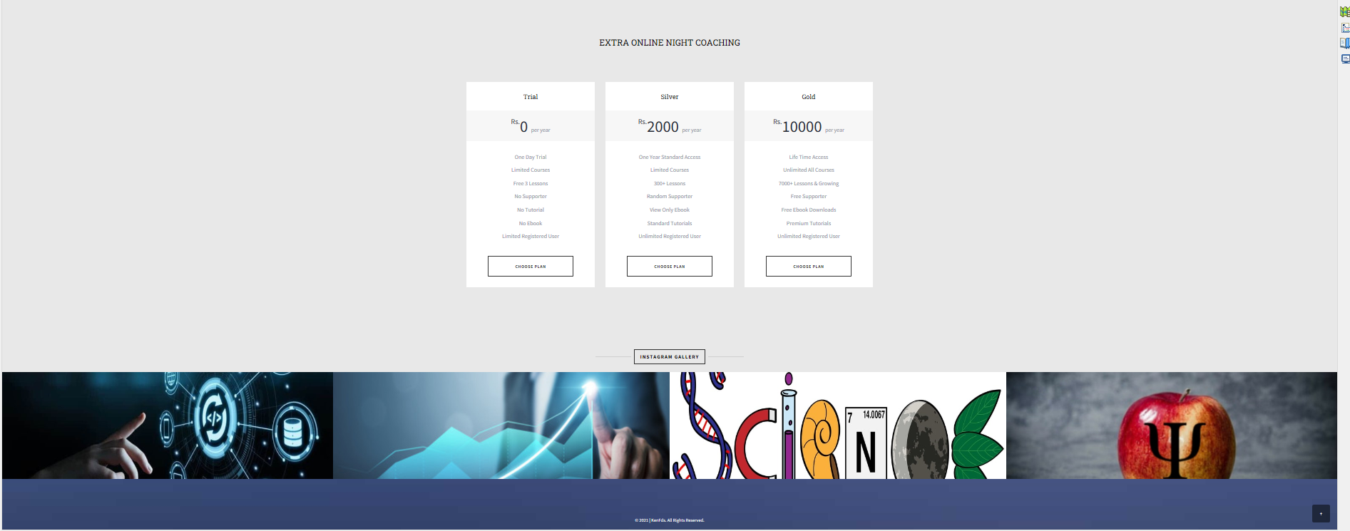

**Courses section:**

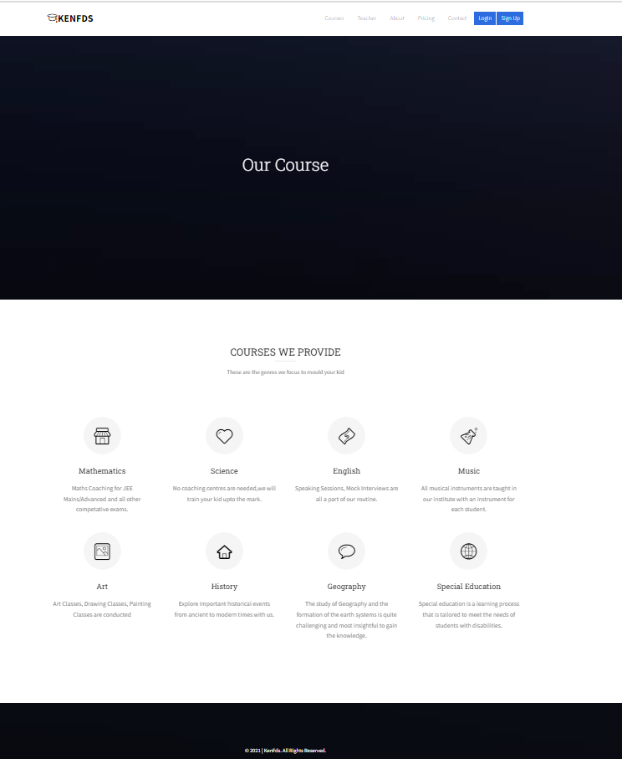

**Teachers section:**

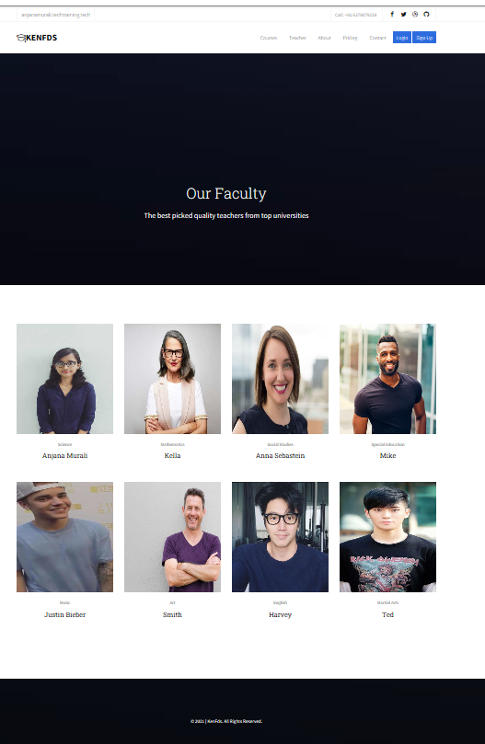

**About section:**

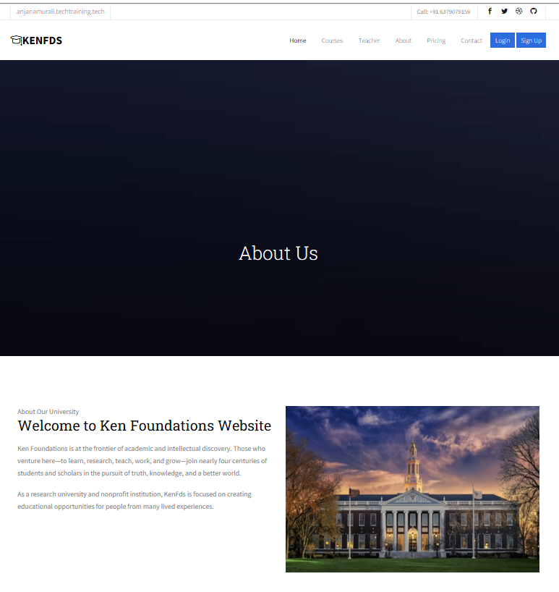

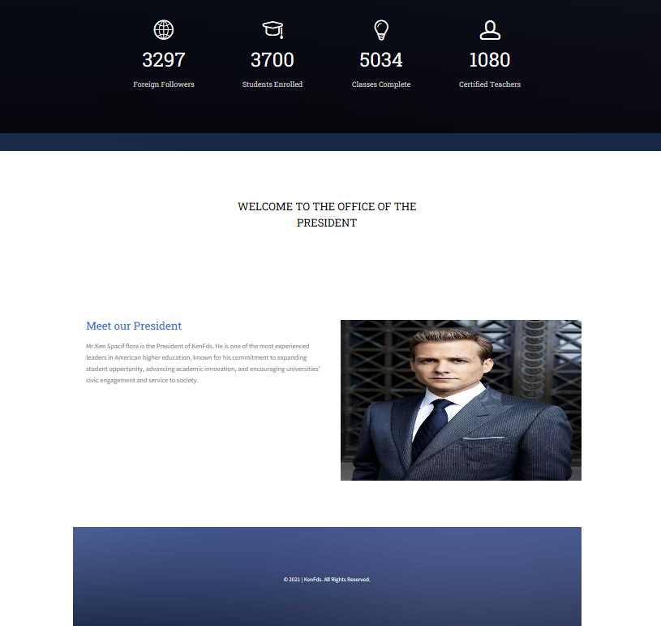

**Price section:**

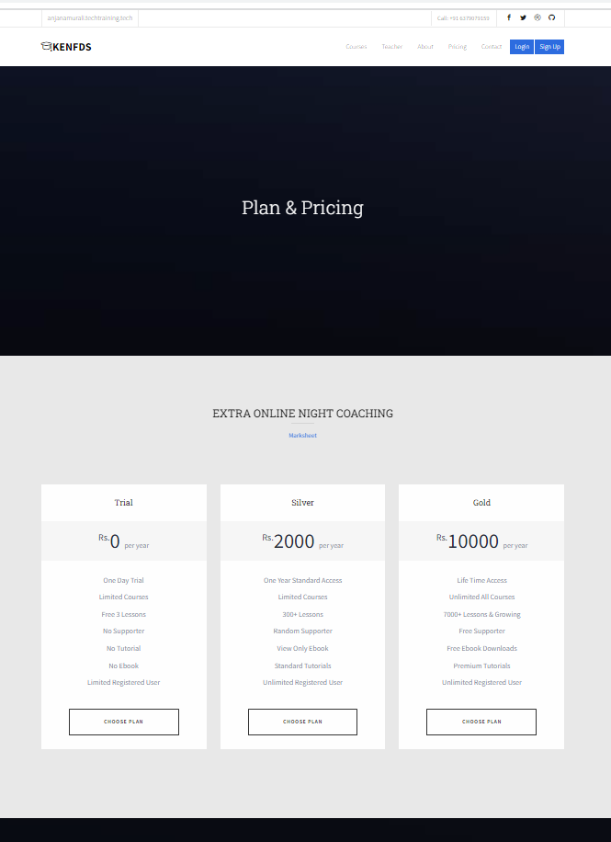

By selecting choose a plan:

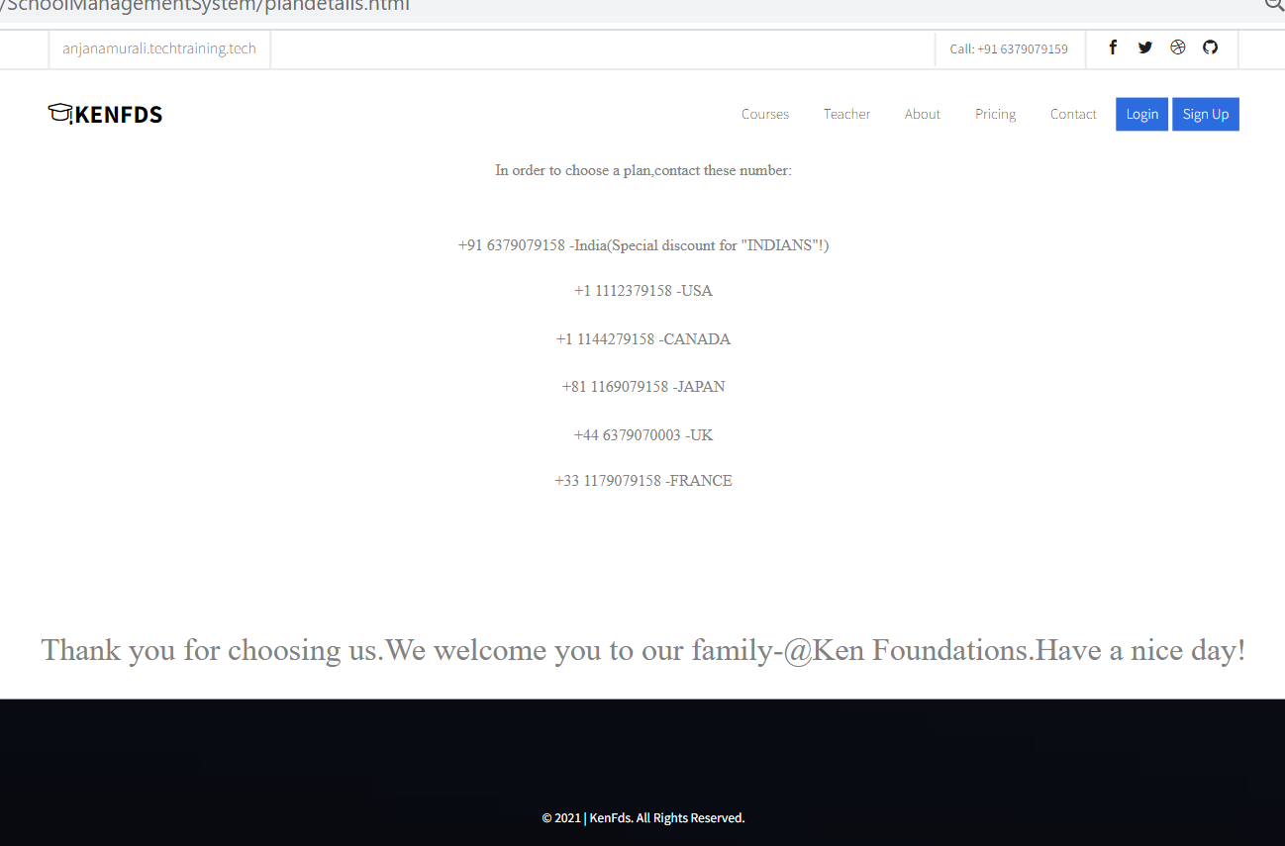

Marksheet :

For getting input:

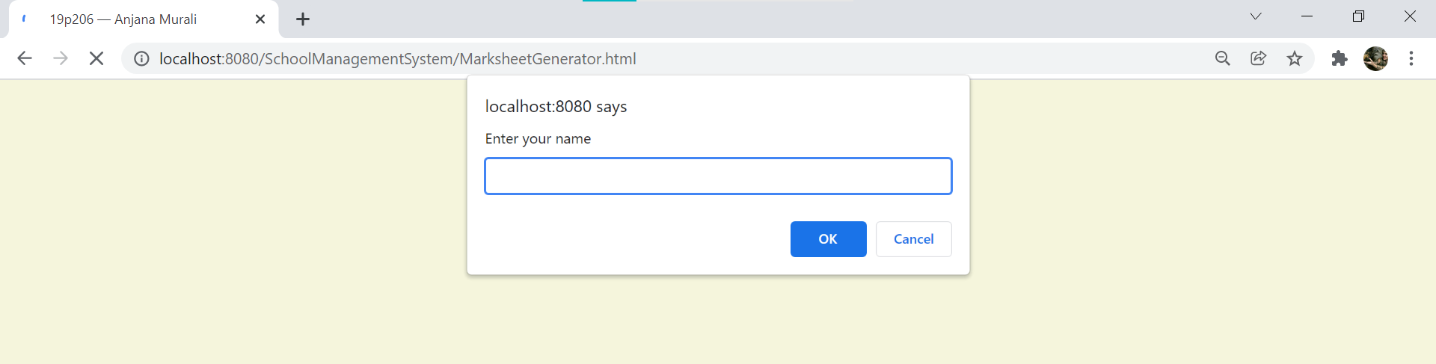

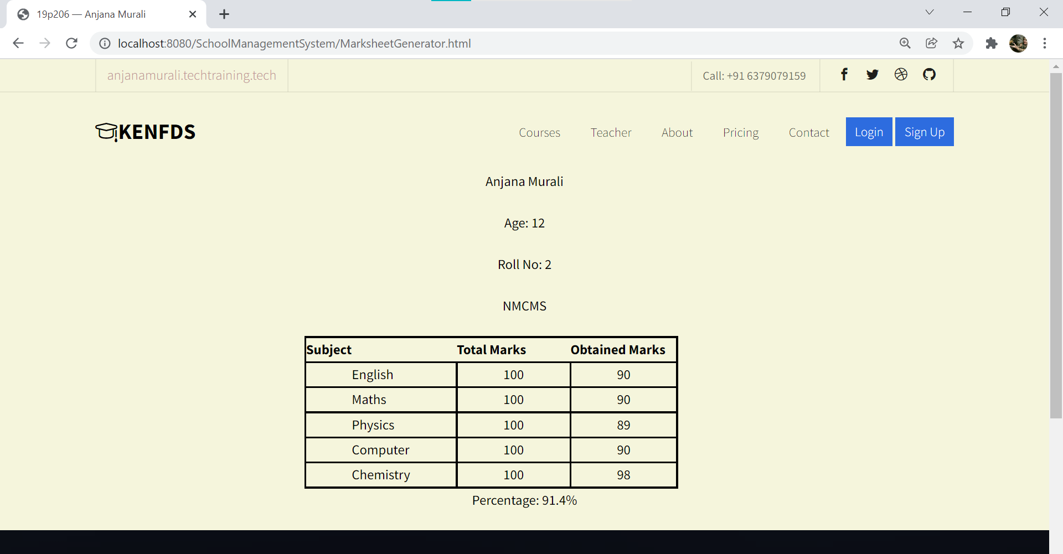

Contact Section:

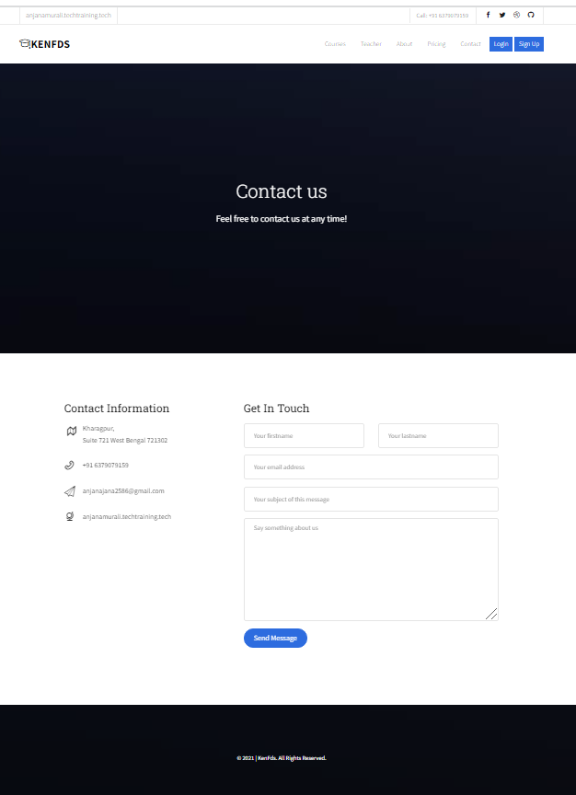

Login section:

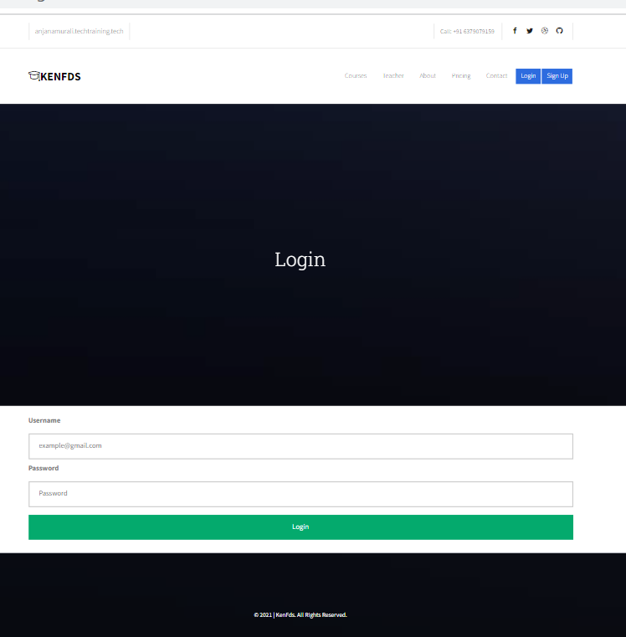

Update Section:

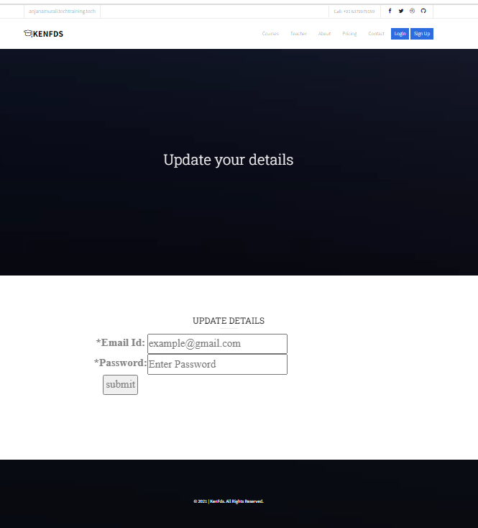

Sign up section:

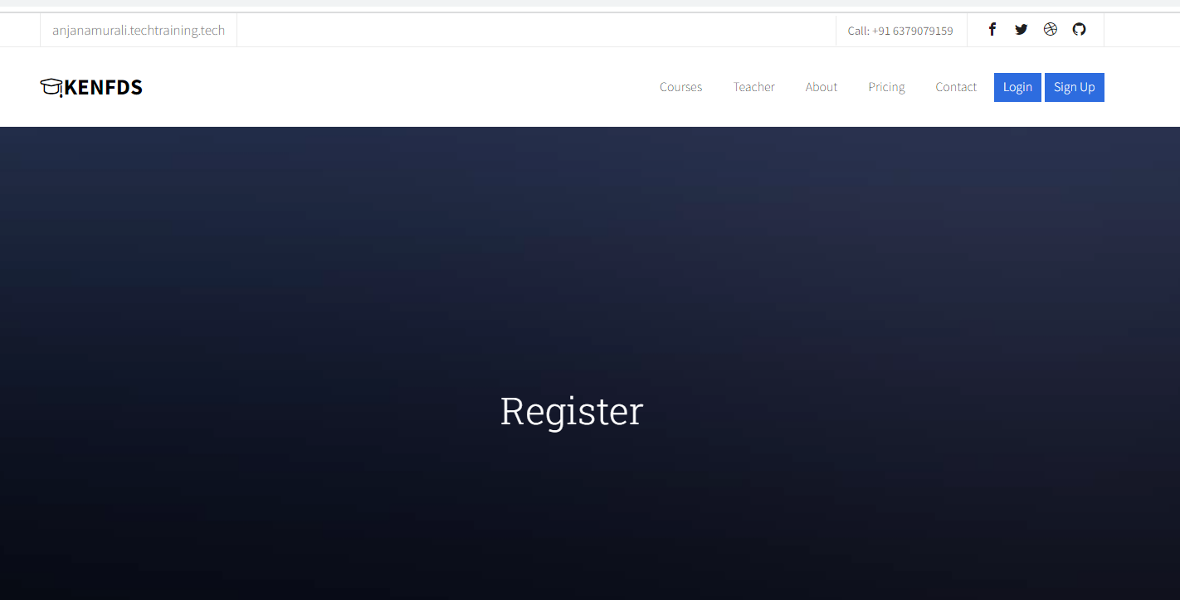

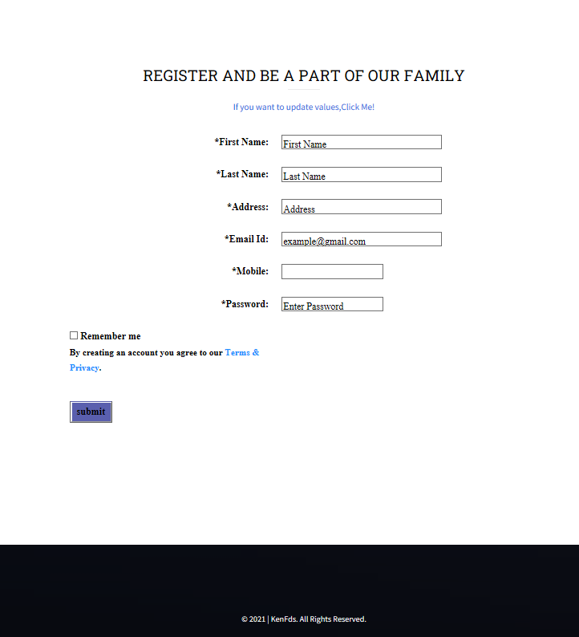

Terms and privacy:

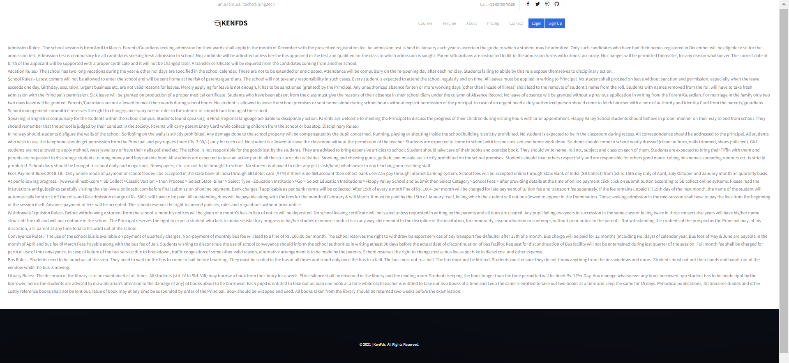

## Assumptions

It is to be assumed that the each individual information will be loaded correctly and performance speed must be high.

# Project IMPLEMENTATION

Bootstrap is used to implement this code.In all section,the navigation bar is designed with logo and social media links so that the user can contact the school. Neccessary fonts, jQuery files and bootstrap files are imported and added.Each sections are linked by html pages.

In home section, Jquery and flex slider is used after the navigation bar so that image shifts from left to right and other image comes in as loop.Owl Carousal is used so that the sentence in the image appears

again and again by specifying the time gap.In courses section, the subjects are mentioned and hover is used on it.In teachers section,images of teachers with their subject is mentioned .In hovering of image,social media links are given so that the user can connect those individuals to clear queries regarding the subjects.In about section ,details about the school and the founder is added along with pictures.In price section, the schedule of online extra night classes along with the cost of the course as trial ,silver and gold is added.By choosing the plan, the user will be redirected to another page where a list of numbers will be given with which they can communicate to respective authorities.Numbers for communication within respective countries are mentioned where the school branches are located.Here,the marksheet can also be viewed after filling certain details asked for. The marksheet is a link which redirects to another page where the necessary details are supposed to be filled so that the marksheet will be generated.In contact module, the user can communicate or clear the queries regarding the academy or courses they provide.Here, the queries are stored in database in a separate table so that the admin can recheck whether they are valid and can be forwarded it to the required individuals.

The system performs various functions like:

Security:

The first function of the system is to provide security from unauthorized access to the data, which is provided with the help of user name & password at the beginning.

Data maintenance:

The most important function of the system is to maintain student data, the data is maintained with the help of different menus like adding, editing etc. There are different kinds of data in the system like personal information, marksheet information,queries & contact details are managed.

**DB Connectivity:**

**Creating separate user :**

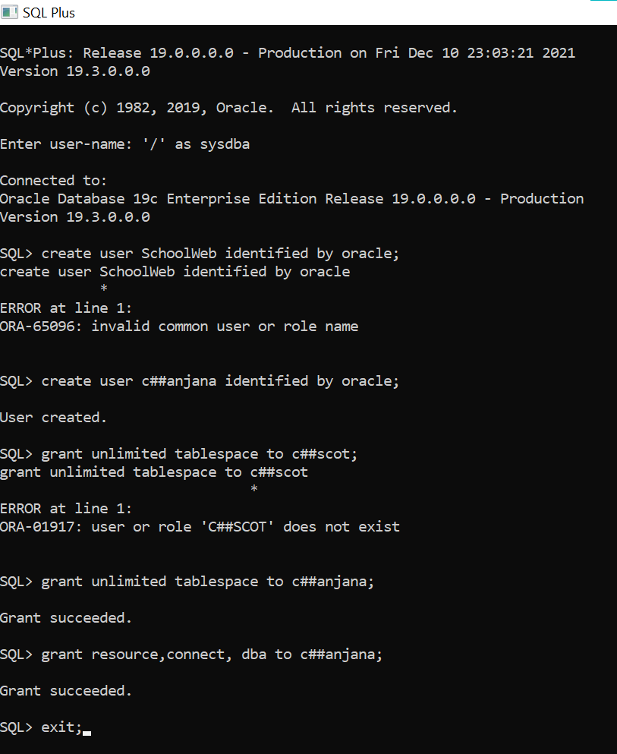

**Creating table:**



**Creating table for contact:**

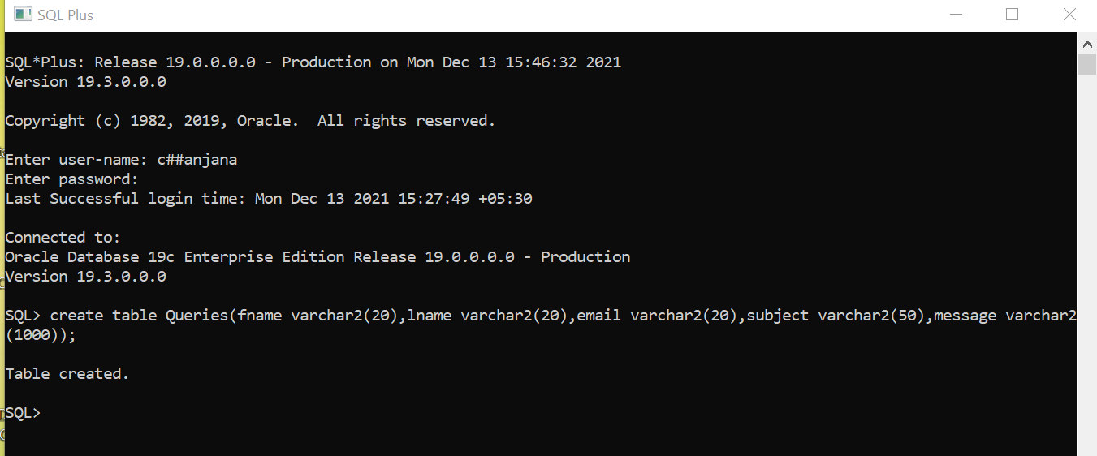

**Updated table:**

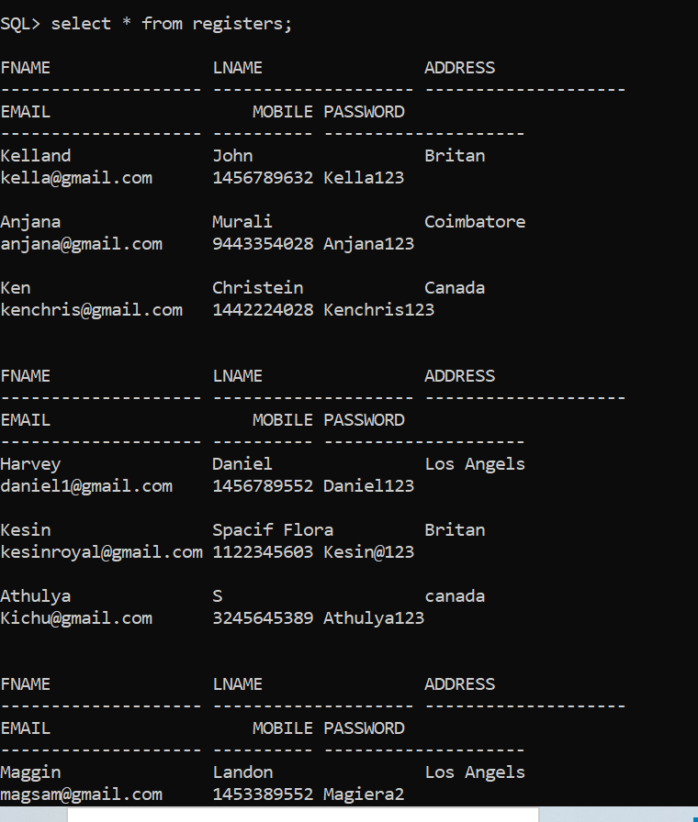

**Queries table:**

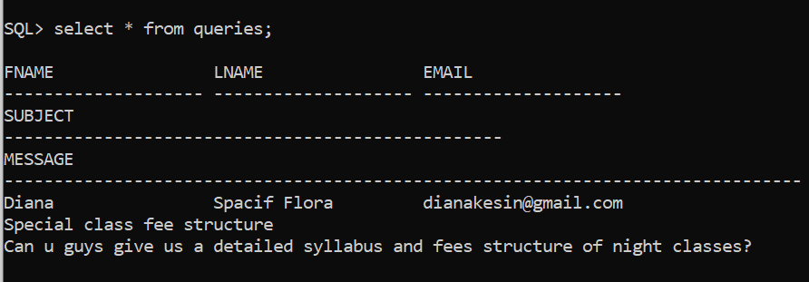

**Validation:**

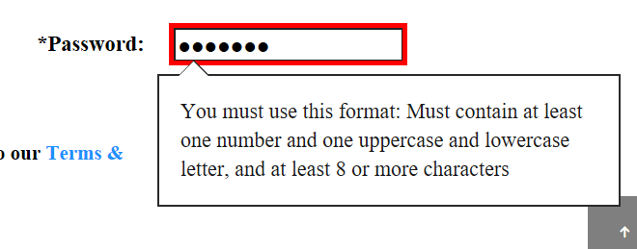



**Servlet Response:**

After Registration: After Login:

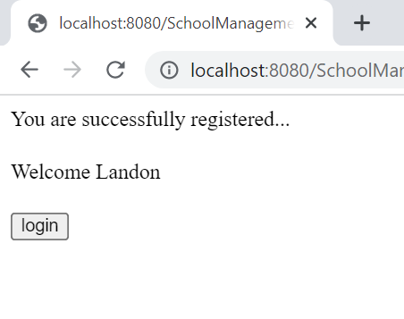

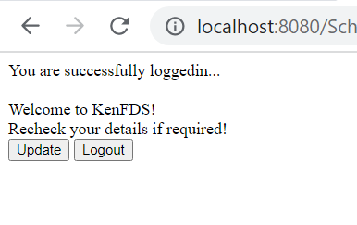

After Update: After submitting query:

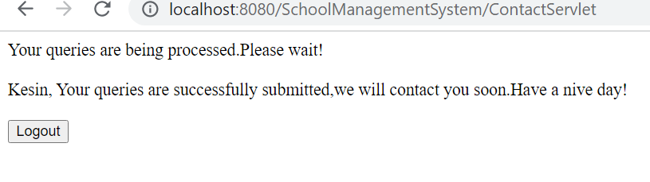

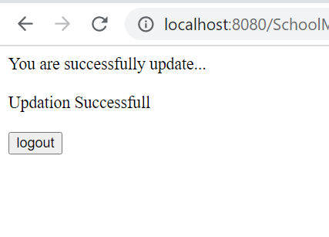

# CONCLUSION

This web based software,The School Management System will bring a great difference in the lives of students, teachers, parents, and the admin. Good management offers better productivity and hence more progress towards development.It helps the school to achieve the target, reduce work, increase efficiency, eliminating error, and monitoring progress.The limitations of the system and future development areas are advance fees calculation. The attendance management will be added if I get a bit more time.High intensive calculation are not included.

# APPENDIX A: LEARNING OUTCOMES

*The learning outcomes for the mini project are focused on the implementation of technical knowledge to address engineering problems, communications, group work, professional and social ethics, sustainability, risk assessment and engineering design practice. The semester long training provides the student with an opportunity to put into practice the skills they have learned in classes. In addition, they will learn to enhance those skills, obtain the perspective of a work environment and benefit from the industry mentor or faculty supervisor’s experience and advice. The workplace creates learning opportunities and it will be central to the student to interact with these possibilities. Therefore, to gain the maximum from the mini project it is important to identify learning possibilities. A key way to do this is by writing the goals of the program as the first report at the end of 3 weeks. The goals must be specific to your training and should be agreed with both your industry mentor and faculty supervisor. Each goal must have specific and clear targets which depict the specific actions and accomplishments that must be completed to reach the goals.*

*The mini project work undertaken is diverse. As a result, the Learning Outcomes will vary, but on completion of the module, students will have achieved several learning outcomes from the following list:*

* *Able to identify and use appropriate mathematical methods, numerical techniques and software tools for application to new and ill-defined engineering problems;*
* *Be able to integrate knowledge, handle complexity and formulate judgements with incomplete or limited information;*
* *Have the ability to redesign products, processes or systems in order to improve productivity, quality, safety and other desired needs;*
* *Have the ability to apply design methods, processes and techniques to unfamiliar, ill-defined problems, involving other disciplines;*
* *Be able to design according to codes of practice and industry standards; to identify limitations of codes of practice and the need for their application;*
* *Have the ability to investigate and define a need and identify constraints including health, safety and legal issues and the impact of engineering solutions in a societal and environmental context;*

# Appendix B: Glossary

HTML: Hyper text markup language

CSS: Cascading Style Sheet

JS: Java Script

J-QUERY: A javascript library

SASS:Syntactically Awesome Stylesheet